**EXPRESSION OF INTEREST (EOI)**

**FOR**

**providing Solution For transportation of Milk in tamper proof, sealed and secured fleet with vehicle tracking system**



**MP State Cooperative Dairy Federation Ltd.**

**Dugdha Bhavan, habibganj, bhopal - 462024**

**Ph: 07552478250 To 253**

**Fax: 0755-2450896**

**Email:** [**ho.mpcdf@nic.in**](mailto:ho.mpcdf@nic.in)

**URL: http:** [**http://mpcdf.nic.in/**](http://mpcdf.nic.in/)

**EOI Notice**

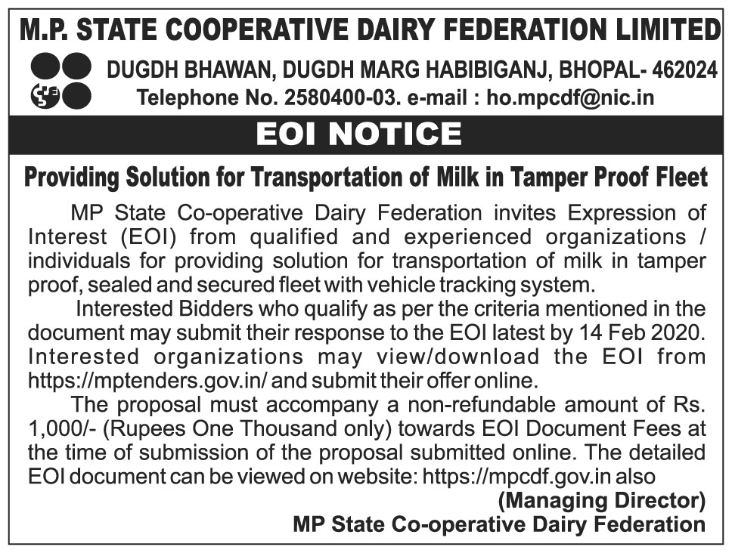

**Table of Contents**

**Acronyms** 4

**Essential Information** 5

**CHAPTER - 1** 6

**1.1** **Information Provided** 6

**1.2** **Disclaimer** 6

**1.3** **Costs Borne by Respondents** 6

**1.4** **No Legal Relationship** 6

**1.5** **Recipient Obligation to Inform Itself** 6

**CHAPTER – 2** 7

**2.1** **Introduction of MPCDF** 7

**2.2 Key Demographics** 8

**2.3 Activities of MPCDF** 8

**2.3 Desired System Characteristics** 9

**3.** **Project Requirement** 9

**3.1** **Scope of Work** 9

**4.** **Eligibility Criteria** 12

**5.** **General** 13

**6.** **Submission of Proposal** 15

**Annexure -1 Format of Application Form** 16

**Annexure -2 Bidder Profile** 17

**Annexure -3 Experience** 18

**Annexure -4 Summary** 19

**Annexure- 5 Checklist** 20

**Acronyms**

|  |  |
| --- | --- |
| GoMP | Government of Madhya Pradesh |
| EOI | Expression of Interest |
| MPCDF | Madhya Pradesh Co-operative Dairy Federation |
| RFP | Request for Proposal |
| DCS | Dairy Co-operative Societies |
| CCs | Chilling Centres |
| BMC | Bulk Milk Coolers |
| VTS | Vehicle Tracking System |
| GPS | Global Positioning System |
| POC | Proof of Concept |
| MD | Managing Director |

**Essential Information**

|  |  |  |
| --- | --- | --- |
|  |  |  |
| **1** | EOI Inviting Authority | MP State Co-operative Dairy Federation (MPCDF) |
| **2** | Date of issuance of EoI | 31/Jan/2020 |
| **2** | EOI Document Fees | Rupees 1,000/- (Rupees One Thousands) to be paid online at <https://mptenders.gov.in/> |
| **3** | Last date for submission of response of EOI | 14 /Feb /2020 up to 3 PM |
| **4** | Place, Date and Time to open the EOI Response | Office of MP State Co-operative Dairy Federation  17/Feb/2020 at 3 PM |
| **5** | Place, Date and Time of Technical Presentation | Technical presentation will held on 25th February 2020 at 11.30 AM at office of MP State Co-operative Dairy Federation, Habibganj, Bhopal |
| **6** | Date Time Place of PoC | The information will be shared after technical presentations |

**CHAPTER - 1**

**1.1 Information Provided**

The **Expression of Interest (EOI)** document contains statements derived from information that is believed to be true and reliable at the date obtained but does not purport to provide all of the information that may be necessary or desirable to enable an intending contracting party to determine whether or not to enter into a contract or arrangement with MPCDF in relation to the provision of services. Neither MPCDF nor any of its officers, employees, agents, representative, contractors, or advisers gives any representation or warranty (whether oral or written), express or implied as to the accuracy, updating or completeness of any writings, information or statement given or made in this EOI document.

**1.2 Disclaimer**

Subject to any law of the country, and to the maximum extent permitted by law, MPCDF and its officers, employees, contractors, agents, and advisers disclaim all liability from any loss or damage (whether foreseeable or not) suffered by any person acting on or refraining from acting because of any information, including forecasts, statements, estimates, or projections contained in this EOI document or conduct ancillary to it whether or not the loss or damage arises in connection with any negligence, omission, default, lack of care or misrepresentation on the part of MPCDF or any of its officers, employees, contractors, agents, or advisers.

**1.3 Costs Borne by Respondents**

All costs and expenses incurred by Recipients / Respondents in any way associated with the development, preparation and submission of responses, including but not limited to attendance at meetings, discussions, demonstrations, etc. and providing any additional information required by MPCDF, will be borne entirely and exclusively by the Recipient / Respondent.

**1.4 No Legal Relationship**

No binding legal relationship will exist between any of the Recipients / Respondents and MPCDF until execution of a contractual agreement.

**1.5 Recipient Obligation to Inform Itself**

The Recipient must conduct its own investigation and analysis regarding any information contained in the EOI document and the meaning and impact of that information.

**CHAPTER – 2**

MPCDF invites **Expression of Interest (EOI)** from qualified and experienced organizations / individuals for milk tanker fleet to overcome adulteration and theft issues during transportation of milk.

**2.1 Introduction of MPCDF**

Madhya Pradesh Co-operative Dairy Federation is the apex organization of the three tier dairy co-operative structure in the state for organized dairy development activities.

At the middle level there are there are six co-operative milk unions across the state under which 7,000 village level Dairy Co-operative Societies (DCS) are functional. The milk is collected through village level DSCs and transported to the dairy plants through 97 chilling centers (CCs) and 600 bulk milk coolers (BMC) through own / hired tankers. The capacity of each tankers varies from 5,000 liters to 27,000 liters and they may have one or chambers as per the design. The total number of tankers currently engaged by milk union are around 150.

The tankers are equipped with GPS and monitored through control rooms at each milk union level. Tankers are sealed at the dispatched point by 5 - 8 seals known as gun-seals, which are put at the inlet and outlet of each tankers. These seals can be opened through cutting only and the serial number of each seal, which is put on the tanker, is mentioned in the challan being carried by the tanker driver.

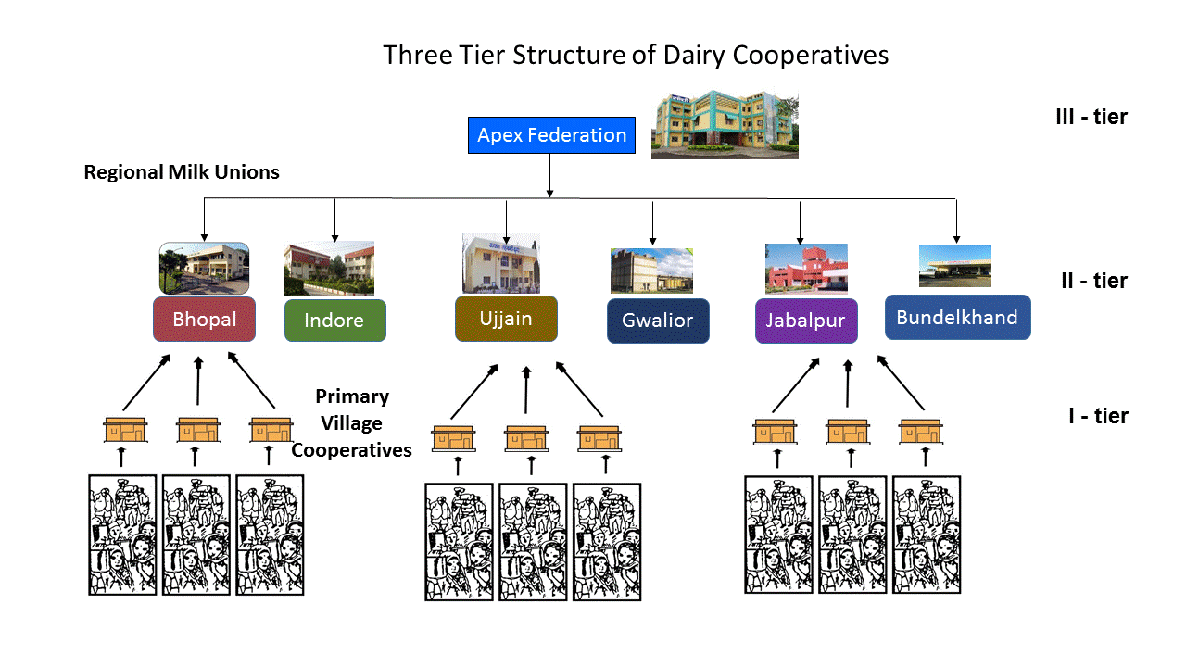

**2.2 Key Demographics**

1. Per capita availability of Milk 505 grams / day with 7.33 Cr. population.
2. Chilling Centers in the entire state – 97
3. Cattle – 1.96 Cr. cows and 81.87 Cr. buffalos
4. The Sanchi ecosystem consisting of milk procurement, processing and distribution in MP with Milk unions and co-operatives manages approximately 10 lac liters of milk per day.

**2.3 Activities of MPCDF**

***Field operations:***

1. Formation, revival and supervision of milk cooperative societies
2. Installation of electronic equipment in milk cooperatives
3. Milk Collection
4. To provide balanced animal feed and mineral mixers at reasonable prices to milk producers.
5. Implementation of fodder development schemes - making available to growers of fodder through mini kit committees from the Government of India
6. Breed improvement through artificial insemination program
7. Animal first aid
8. Support for animal loans
9. Implementation of state and central government schemes

***Plant Operations:***

1. Chilling and processing of milk received from village level dairy cooperative societies
2. Manufacturing and packing of different types of milk
3. Manufacturing of various milk products like Ghee, White Butter, Table Butter, Skimmed Milk Powder, Shrikhand, Plain Curd, Sweet Curd, Lassi, Butter Milk, Paneer, Mawa, Chhena Kheer, Milk Cake, Gulab Jamun & Rasgulla
4. Compliance of FSSAI standards

***Marketing:***

1. Distribution of milk & milk products to various retailers spread over in all parts of the State.
2. Organization of various promotional activities like "Sanchi Utsav" for sales promotion
3. Discovery of new markets for Sanchi milk and milk products
4. Efforts for export of Sanchi milk products

**2.3 Desired System Characteristics**

Since transportation of pure milk without theft and adulteration is one of the most important activities of MPCDF hence it is decided to secure the tankers using latest technology such as secure locks, surveillance, monitoring, digital locking, geo fencing, GPS Tracking etc. The proposed solution will provide inputs, which will form the base for the tender document. All type of charges of the complete solution for example SIM card, Internet connection charges shall be borne by the successful bidder after selection through e-tender. The System shall be scalable & modular and capable of handling at least 40% additional number of milk tankers.

**3. Project Requirement**

**3.1 Broad scope of Work**

1. The broad Scope of work includes Design, Develop, Supply, Installation and Commissioning and Customization, implementation of a solution that meets the norms of the central and state governments. The complete solution should include dashboard, Vehicle Tracking Systems, Computer hardware and related peripherals, connectivity, manpower deployment, training to users, handholding support and Operation & Maintenance etc. The project duration is of five years.
2. MPCDF is in planning to secure the entire fleet used in transportation of milk. The proposed solution should be able to carry out at least the below mentioned functionalities:

**Vehicle Tracking System:**

Tracking of vehicles on real time basis while it is in transit to monitor that it is on designated route. Functionality such as searching of vehicles using different parameters.

**Geo- fencing:**

Setting up the boundaries for the tanker vehicles where they are allowed to operate. Get instant notifications in case vehicle goes out of specific boundaries

**Surveillance:**

Surveillance system to monitor all activities such as opening, closing of the tankers (inlet and outlet) etc. Ability of the system to stop any unlawful activity from the central command and control center

**Software controlled lock system:**

The electronic locking system should be free from complex key management type system and should be tamper proof. The software should also have the provision to handle emergencies related to transportation of milk. The GUI should be user friendly. The system should have the capability of planning the route with multiple alternate routes. The system should have the capability to gather the data and at any point of time and provide status such as which tanker is carrying how much liters of milk, how many tankers have collected from pick up point etc.

**Audit logs & Alerts:**

The system should maintain audit log of every activity and should generate alerts in the form of SMS, mail, alarm or any other suitable form to designated officers. There should be time stamping at defined activities. The gathered data should support in identifying the location of theft and tampering activities.

**Command and control Centre:**

Establishment of command and control center with / without manpower for taking actions such as immediate action on the alerts, analysis of data, generation of reports, manage the diversion of the route in software, managing electronic lock related issues etc.

**Standards of the devices:**

All devices used in the solution must meet standards issues by national and international bodies in their particular domain. The devices must be strong enough to perform in harsh environmental conditions. The devices attached with the milk tankers should be self-powered with auto charging from vehicle. The system must be safe and having necessary statutory approvals.

**Application related:**

The application should support Hindi & English language and mobile app should be able to carry out the major functionality. Application design, development, installation, configuration & maintenance will be taken care by the successful vendor selected through tender. The vendor will have to maintain the application during the project period. In case of change request (other than the scope of work) proposal will be shared after estimating the efforts. MPCDF will provide all the master data such as district, block, route mapping etc. for entering the same application. The solution should support integration to other systems in future.

1. Bidder should propose the BoM (Bill of Material) & required minimum specification of the hardware at both Server and client end according to their solution proposed in response to EOI. The proposed solution should be redundant with provision of power supply and backup.
2. For Connectivity at tankers / client locations, Bidder should propose cost effective solution (medium of connectivity, network equipment etc.) in their response. Technical document on approach & methodology to provide connectivity should be submitted along with response.
3. Master Data: Master data of district, tehsil, milk fleet etc. with mapping will be provided in soft copy to the successful bidder selected through tender method.
4. Bidder has to submit complete plan including the manpower deployment plan for command and control Centre, approach & methodology, imparting training etc.
5. Bidder has to provide Annual Maintenance Contract related details also.

1. **Eligibility Criteria**
2. The bidder should be a legal entity in India. Incorporation/Registration certificate should be furnished as documentary proof such as MOA/AOA/By-Laws.
3. The organization should be a profit making company with annual average turnover of Rs. 5 Crore or more for the last 3 years and it should be in the business of IT equipment, software development etc. CA certificate or copies of audited accounts with balance sheet, profit & loss A/c should be submitted as documentary proof.
4. The organizations having experience in implementation of similar kind of projects, will be given preference to participate in the EOI. Copy of work order/ PO along with experience certificate should be enclosed with proposal.
5. Technical quality parameters in the software development, deployment/System integrator experience as to be listed as per Annexure -2, shall be used to evaluate the bidders.
6. **General**
7. This is not a **Request for proposal (RFP)** and **commercial bids** SHOULD NOT be submitted with EOI.
8. **MPCDF** reserves the right to examine / verify the supportive documents / reports furnished by the bidders.
9. **MPCDF** would constitute an evaluation committee that will evaluate the responses in detail in order to determine whether they are substantially responsive to the requirements set forth in the EOI. The decision taken by the committee in this regard is final and binding on all the bidders of EOI. Experts other than MPCDF may be added in the committee.
10. **MPCDF** shall shortlist the vendors based on the requirements and the responses submitted. MPCDF reserves the right to call only short listed vendors for a **technical** **presentation / demo** of their proposed solution on the date and time decided by MPCDF. The decision taken by the MD, MPCDF in this regard would be final and binding on all the bidders of EOI.
11. The **Technical presentation** should have following contents:
    1. Previous experiences of the similar project implemented & Challenges faced during implementation
    2. Understanding of requirement for which the project was executed.
    3. Proposed business model (BOO, BOOT etc.)
    4. Demonstration of software solution along with all the proposed modules.
    5. Details of the hardware & related peripherals proposed.
    6. Manpower deployment plan for the project
    7. Methodology and Approach for training
    8. Connectivity - Approach & Methodology
    9. Project implementation Plan & timelines
    10. Operation & Maintenance phase – proposed plan
    11. Redundancy of system
    12. Exit plan
    13. Any other relevant information
    14. approximate cost of the solution
12. The vendor presentation / demonstration of the product shall be held at **Office of the Madhya Pradesh Co-operative Dairy Federation, Bhopal**.
13. If any information or document provided in the response to this EOI is found to be misleading subsequently, the bidder will be disqualified.
14. MD, MPCDF may reject any or all the responses received / cancel the entire process at any stage without assigning any reason whatsoever.
15. MPCDF shall have absolute discretion to issue **Request of Proposal** to eligible bidders shortlisted under EOI or to go for open tender later as per the requirement.
16. The applicants who wish to submit responses to this EOI should note that they should abide by all the terms and conditions contained in the EOI. If the responses contain any extraneous conditions put in by the respondents, such responses may be disqualified and may not be considered for the empanelment / selection process.
17. The information exchanged between the bidders and MPCDF as part of this EOI shall be confidential and shall not be disclosed without the prior written consent of the MPCDF.
18. MPCDF will conduct a PoC, the details of the same will be shared with the organizations participating in this EoI.
19. Notwithstanding anything contained herein above, in case of any dispute, claim and legal action arising out of this EOI, the parties shall be subject to the jurisdiction of courts at Bhopal, Madhya Pradesh State, India only.
20. **Submission of Proposal**

Bidders qualifying as per the criteria mentioned above and who are interested in providing the services detailed above may submit their response to this EOI as per formats given in annexure along with relevant documentary evidence as per the date and time mentioned in the essential information section.

The response should contain all the necessary annexures, documents related to this EoI, proposed solution, data sheets etc.

Any response not containing information for all the parts of Annexure may be rejected.

The non-refundable amount of **Rs. 1,000/-** (Rupees One Thousand only) towards EOI Document Fees is to be submitted online.

# Annexure -1 Format of Application Form

(On Applicant Organization's Letterhead)

**To,**

**Subject:** Expression of Interest for …………

**Dear Sir,**

This has reference to the EoI published on <https://mptenders.gov.in> on the date…….. pertaining to the above captioned subject.

We are interested in submitting our response to Expression of Interest. We are submitting Rs.1,000**/-** (Rupees One Thousand Only) online as document fee for participating in this EOI.

We would like to clearly state that we qualify for this work as our organization meets all the pre-qualifying criteria indicated by you and our organization is not under a declaration of ineligibility for corrupt or fraudulent practices.

We understand that if the details given in support of claims made by us are found to be untenable or unverifiable or both our EOI will be rejected without any reference to us. We further clearly understand that MPCDF is not obliged to inform us of the reasons of rejection of our bid.

**Yours sincerely**

**Authorized Signatory**

<<Name, designation, contact address, telephone number, email & seal of authorized signatory >>

**Note: Bidder has to submit the Authorization letter/Power of Attorney of the authorized person to sign to the Application form and other documents submitted in response to EOI on behalf of bidder.**

**Annexure -2 Bidder Profile**

|  |  |  |
| --- | --- | --- |
| **S/N** | **Particulars** | **Response** |
| 1 | Company Name |  |
| 2 | Date of incorporation |  |
| 3 | Company Head Office Address |  |
| 4 | Registered office address |  |
| 5 | Contact person Name |  |
| 6 | Address |  |
| 7 | Telephone no. |  |
| 8 | Mobile No. |  |
| 9 | Fax No. |  |
| 10 | e-mail ID |  |
| 11 | Number of year experience in implementation of similar kind of projects. |  |
| 12 | Whether company has been blacklisted for service deficiency in last 3 years. If yes, details thereof. |  |
| 13 | Annual average turnover for Financial Years 2016-17, 2017-18, 2018-19 ( CA certificate ) |  |
| 14 | Net profit for year 2018-19 ( CA certificate ) |  |
| 15 | Any Quality Certifications obtained (i.e. ISO, CMM, etc.). Submit details. |  |
| 16 | Office & Service Centre detail in Madhya Pradesh (if any) |  |
| 17 | Size of the projects implemented in term of project value, no. of location, scope of work etc. |  |
| 18 | Detail of the manpower proposed for this project i.e. no. of manpower/Resources their Qualification/ experience etc.) |  |
| 19 | Existing Staff strength of the Company |  |
| 20 | Whether ready to bid as primary bidder and undertake to provide the products and services indicated in the scope of EOI. |  |

**Annexure -3 Experience**

Submit following details separately for each of the implementation site (one duly filled format for each client.).

|  |  |  |
| --- | --- | --- |
| **S/N** | **Particulars** | **Response** |
| 1 | Organization in India where the proposed solution is already implemented by the bidder & running successfully. ( if any ) |  |
| 2 | Address of a contact person at above Organization |  |
| 3 | Name |  |
| 4 | Designation |  |
| 5 | Mobile No: |  |
| 6 | Email |  |
| 7 | Contract date |  |
| 8 | Number of locations |  |
| 9 | Time taken for implementation of the solution from the date of Purchase Order / signing of contract |  |
| 10 | Whether the scope for this engagement covered all the modules indicated in Scope of this EOI. If not, list the modules implemented. |  |
| 11 | Customer satisfactory letter/client certificate if any. |  |

**Annexure -4 Summary of Solution**

|  |  |  |
| --- | --- | --- |
| **S/N** | **Particulars** | **Response** |
| 1 | Brief detail of solution |  |
| 2 | Digital Lock details |  |
| 3 | Vehicle tracking system details |  |
| 4 | Other survelience details |  |
| 5 | Alarm / allerts / SMS facility details |  |
| 6 | Operational requirements (Internet / 4G / 3G/ 2G) |  |
| 7 | Alternative operational arrangements |  |
| 8 | Approx. cost of solution |  |
| 9 | Approx. maintenance requirement |  |
| 10 | Warranty of solution |  |
| 11 | Expected life cycle of solution |  |
| 12 | Constraints, if any |  |

**Annexure -5 Checklist**

The bidder has to submit the following documents as a part of proposal:

|  |  |  |
| --- | --- | --- |
| **SI. no.** | **Documents/Response** | **Submitted (Y/N)** |
| **1** | Application Form *(Annexure 1)* |  |
| **2** | Bidder Profile *(Annexure 2)* |  |
| **3** | Experience *(Annexure 3)* |  |
| **4** | Incorporation/Registration certificate should be furnished as documentary proof along with MOA/AOA/By-Laws. |  |
| **5** | CA certificate / Audited Balance Sheet & Profit & Loss A/c |  |
| **6** | Copy of work order/ PO along with experience certificate |  |
| **7** | Technical document as per scope of work covering at least the following:-  • Application Software  • Computer hardware  • Connectivity  • Manpower deployment plan  • Training  • Handholding support  • Operation & Maintenance  • Standards of national and international level followed |  |
| **8** | Any other document if required |  |

**End of Document**